ECE – 3441: Digital Logic Design
Lab 5: 4 Bit Calculator.
Anaya Scott

Overview:
The goal of this lab was to implement the understandings from Lab 4, a 4 but adder/ subtractor calculator into a circuit using basic logic gates. Gates like AND, OR, XOR, and NOT instead of using the full adder chip. This lab involved the understanding of Boolean expressions for the Sum and the Carry out/ in to simulate the full circuit in the software SimUAid. And then building the expression using TTL chips that could perform both function of the adder and subtractor using 2’s complement binary.

Procedures and Results
- How many 2-input gates are required to implement the minimum SOP of Sn?
  - 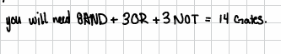
- . How many 2-input gates are required to implement the minimum SOP of Cn+1?
  - 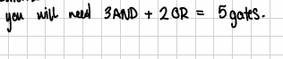
- How many gates for one full adder and four full adders?
  - 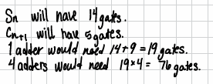
- Prove Sn = An ⊕ Bn ⊕ Cn and gate count
  - 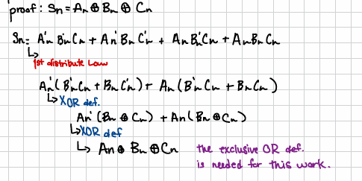
- . Prove Cn+1 = AnBn + Cn (An ⊕ Bn) and gate count
  - 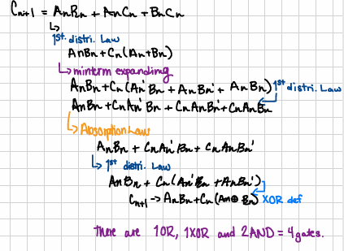
- Can gates be shared between Sn and Cn+1? How many total gates then?
  - 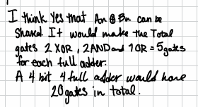
- Is the minimum SOP always the best to build in hardware?
  - 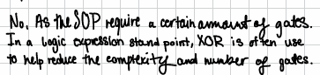
- Simulated Circuit Build
  - 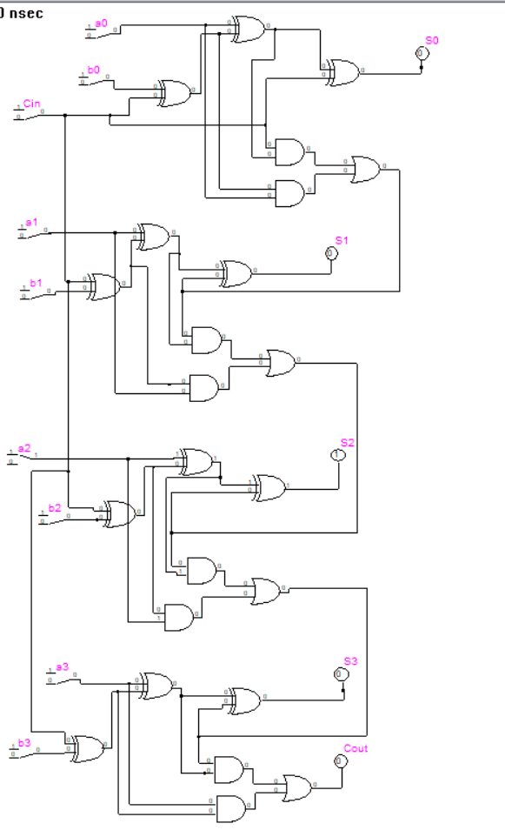
Figure 1: Simulated Full adder.
- . Range of Two’s-Complement Values For 4-bit two’s complement:
  - 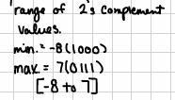
- Four Examples of A + B
A (dec) | B (dec) | A (bin) | B (bin) | Cin | Sum (dec) | Sum (bin)
+5 | +3 | 0101 | 0011 | 0 | +8 | 1000
+3 | -2 | 0011 | 1110 | 0 | +1 | 0001
-2 | +6 | 1110 | 0110 | 0 | +4 | 0100
-4 | -2 | 1100 | 1110 | 0 | -6 | 1010
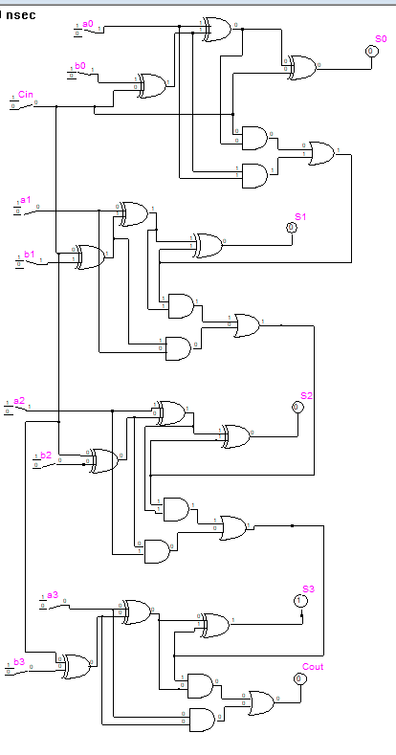
Figure 2: +5 +(+ 3) = +8. This creates an overflow.
- Four Examples of A – B
A (dec) | B (dec) | A (bin) | B (bin) | Cin | Sum (dec) | Sum (bin)
+4 | +2 | 0100 | 0010 | 1 | +2 | 0010
+5 | -1 | 0101 | 1111 | 1 | +6 | 0110
-6 | +1 | 1010 | 0001 | 1 | -5 | 1011
-3 | -4 | 1101 | 1100 | 1 | -7 | 1001
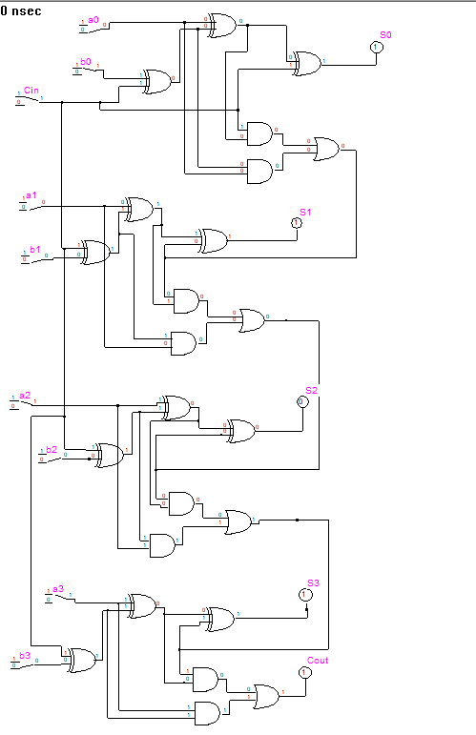
Figure 3: -6 - (+1) = -5.
- What resistor values are used and why?
  - I used a range of 510 – 200 Ω resistors as pull-down resistors to help distribute the power more efficiently from the 9 [V] that I was using. This helped prevent unpredictable reactions in the chips and the circuit.
- Performed the demonstration in person.

Conclusion
In conclusion, doing this lab provided a deeper understanding om how to build and debug a 4-bit full adder/subtractor calculator with logic gates. By using Boolean expression schematics to simulate and build the physical device, I learned how logic simplification would lead to a better way for real world applications. I also got to practice using 2’s complement binary system and hardware debugging. Which overall made a great way to build upon the skills that are going to be needed later on.

